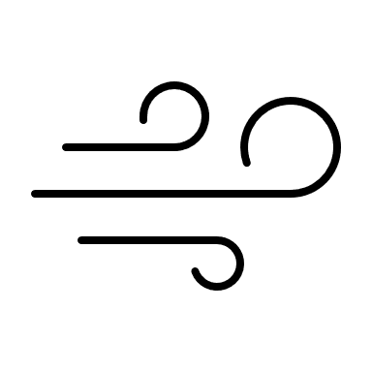

**NAME:**

**NAME:**

**DATE ____/_____/__________**

**DATE ____/_____/__________**

**Weather**

* Bees are actively flying in an out. Y N
* Bees conducting orientation flights. Y N
* Swarm has landed near the hive. Y N
* Forager bees are bringing back pollen. Y N
* Any attacking robber bees or wasps? Y N
* Dead/weak/struggling bees at entrance. Y N
* Hive box, lid, base are intact. Y N
* Evidence of other animal or pest invasion. Y N

**Exterior Observations**

Notes:_____________________________________________________________________________________________________________________________________

Notes:___________________________________________________________________________________________________________________________________________________________________________________________________________________________________________________________________________________________________________

**Wax Moth**  Y  N

**Small Hive Beetle**  Y  N

**DISEASE/PESTS**

**QUEEN/BROOD**

* Saw the queen Y N
* Queen Cells?  Y  N Quantity: _______ Removed?  All  Some  None
* Eggs/Larvae?  Y  N  Healthy/White  Discoloured  Brown/Black
* Capped Brood  Y  N  Healthy  Pierced  Sunken  Greasy
* Brood Pattern:  Oval/Centred  Uniform  Solid  Spotty  Shotgun
* Brood Quantity since last inspection?  Increased  Decreased
* % Drone Brood ________%
* Done Brood since last inspection?  Increased  Decreased

**GENERAL**

**Weather**

______C

Temp:

* Bees are actively flying in an out. Y N
* Bees conducting orientation flights. Y N
* Swarm has landed near the hive. Y N
* Forager bees are bringing back pollen. Y N
* Any attacking robber bees or wasps? Y N
* Dead/weak/struggling bees at entrance. Y N
* Hive box, lid, base are intact. Y N
* Evidence of other animal or pest invasion. Y N

**Exterior Observations**



______C

Notes:_____________________________________________________________________________________________________________________________________

Temp:

* Bee temperament  DOCILE  CURIOUS/BUZZY  AGGRESSIVE/STINGING
* Frame coverage with bees?  SPARCE  SINGLE LAYER  DOUBLE LAYER
* Bees hanging from bottom of framer? Y N
* Population since last inspection?  SAME  INCREASE DECREASE
* Bees actively walking around frames? Y N
* Any struggling, weak or listless bees? Y N
* Approximate #/% drones? ___________

**Interior Observations**

* Saw the queen Y N
* Queen Cells?  Y  N Quantity: _______ Removed?  All  Some  None
* Eggs/Larvae?  Y  N  Healthy/White  Discoloured  Brown/Black
* Capped Brood  Y  N  Healthy  Pierced  Sunken  Greasy
* Brood Pattern:  Oval/Centred  Uniform  Solid  Spotty  Shotgun
* Brood Quantity since last inspection?  Increased  Decreased
* % Drone Brood ________%
* Done Brood since last inspection?  Increased  Decreased

**Interior Observations**

**DISEASE/PESTS**

**GENERAL**

* Bee temperament  DOCILE  CURIOUS/BUZZY  AGGRESSIVE/STINGING
* Frame coverage with bees?  SPARCE  SINGLE LAYER  DOUBLE LAYER
* Bees hanging from bottom of frames? Y N
* Population since last inspection?  SAME  INCREASE DECREASE
* Bees actively walking around frames? Y N
* Any struggling, weak or listless bees? Y N
* Approximate #/% drones? ___________

**Nosema\*\***  Y  N **Varroa\*\***  Y  N **Other?**  Y  N

Notes:____________________________________________________________________________________________________________________________________________________________________________________________________________________________________________________________________________________________________________

**Chalkbrood\*\***  Y  N

**EFB\*\***  Y  N

**AFB\*\***  Y  N

**Wax Moth**  Y  N

**Nosema\*\***  Y  N **Varroa\*\***  Y  N **Other?**  Y  N

**Chalkbrood\*\***  Y  N

**AFB\*\***  Y  N

**EFB\*\***  Y  N

**Small Hive Beetle**  Y  N

**QUEEN/BROOD**